**­­ ASSIGNMENT 1 FRONT SHEET**

|  |  |  |  |
| --- | --- | --- | --- |
| **Qualification** | **BTEC Level 5 HND Diploma in Computing** | | |
| **Unit number and title** | Unit 06: Managing a Successful Computing Project | | |
| **Submission date** | 22 October 2023 | **Date Received 1st submission** |  |
| **Re-submission Date** |  | **Date Received 2nd submission** |  |
| **Student Name** | Truong Duong Hong Phuoc | **Student ID** | GCC210321 |
| **Class** | GCC1001 | **Assessor name** | Tran Thi Kim Khanh |
| **Student declaration**  I certify that the assignment submission is entirely my own work and I fully understand the consequences of plagiarism. I understand that making a false declaration is a form of malpractice. | | | |
|  |  | **Student’s signature** |  |

**Grading grid**

|  |  |  |  |  |  |  |
| --- | --- | --- | --- | --- | --- | --- |
| P1 | P2 | P3 | P4 | M1 | M2 | D1 |
|  |  |  |  |  |  |  |

|  |  |  |
| --- | --- | --- |
| **❒ Summative Feedback: ❒ Resubmission Feedback:** | | |
| **Grade:** | **Assessor Signature:** | **Date:** |
| **IV Signature:** | | |

Unit 06: Planning a Computing Project

Assignment Brief 1

|  |  |
| --- | --- |
| Unit Number and Title | Unit 06: Planning a Computing Project |
| Academic Year | 2023 - 2024 |
| Unit Tutor | Nguyen The Lam Tung |
| Assignment Title | Plan and conduct a small scale research activity |
| Issue Date | 01 September 2023 |
| Submission Date | 01 August 2023 |
| Submission Format | |
| |  |  | | --- | --- | | *Format* | The submission is in the form of an individual written report that shows how you have manage the project. This should be written in a concise, formal business style using single spacing and font size 12. You are required to make use of headings, paragraphs and subsections as appropriate, and all work must be supported with research and referenced using the Harvard referencing system. Please also provide a bibliography using the Harvard referencing system. | | *Submission* | Students are compulsory to submit the assignment in due date and in a way requested by the Tutors. The form of submission will be a soft copy in PDF posted on corresponding course of <http://cms.greenwich.edu.vn/> | | *Note* | The Assignment must be your own work, and not copied by or from another student or from books etc. If you use ideas, quotes or data (such as diagrams) from books, journals or other sources, you must reference your sources, using the Harvard style. Make sure that you know how to reference properly, and that understand the guidelines on plagiarism. *If you do not, you definitely get fail*. | | |
| Unit Learning Outcomes | |
| LO1: Establish project aims, objectives and timeframes based on the chosen theme.  LO2: Conduct small-scale research, information gathering and data collection to generate knowledge to support the project. | |
| Transferable skills and competencies developed | |
| The assignment offers students the chance to explore various aspects of big data from the perspective of computing professionals or data scientists. It also encourages investigations into the applications, benefits, limitations, and responsibilities associated with big data and provides solutions to the problems it aims to solve. | |
| Vocational scenario | |
| Introduction to theme  Application of Big Data and IoT/AI to potential future developments  Over the past decade, the term "big data" has gained increasing popularity. Initially, it referred to data generated in massive volumes, such as internet search queries, weather sensor data, and social media information. Nowadays, big data represents large amounts of information from diverse sources that cannot be processed conventionally or without computational intervention. Big data can be stored in structured, unstructured, or semi-structured formats. Many systems and organizations generate massive quantities of big data on a daily basis, some of which are publicly available for analysis. Consequently, machine learning systems have been developed to sift through this data, rapidly identify patterns, and solve problems. This has led to the emergence of data science analytics as a discipline to design, build, and test machine learning and artificial intelligence systems. Leveraging big data requires a broad range of knowledge and skills, creating new opportunities for previously inaccessible organizations. It allows businesses to gain a comprehensive understanding of global trends, enabling more accurate and up-to-date decision-making. Big data can help identify potential business risks earlier and minimize costs without compromising innovation. However, the rapid application of big data raises concerns about security, the ethical storage of personal data from multiple sources, and the sustainability of energy requirements in large data warehouses.  Task  As a member of Research and Development department, you have been assigned a mini-project to find out the application of Big Data and IoT/AI to potential future developments e.g. automated manufacturing, medicine and healthcare, virtual worlds, scientific research, etc. | |
| Assignment activity and guidance | |
| You need to do primary research (both qualitative and quantitative research) and secondary research to find out that impact and conduct a report for your research. Even it’s a mini-project, you must apply project management (PM) techniques such as project charter with aims, objectives, cost etc. As for time management, you need to produce WBS and Gantt chart with reasonable tasks and time. A project logbook is required to provide evidence of the project development process and ongoing reflection for every week. This logbook will be needed later for your reflection and evaluation in Assignment 2. As part of QA (quality assurance) policy, in the report you also need to critically evaluate the PM process and appropriate research methodologies applied.  Your report must have an introduction stating the project aims and objectives. This must be followed by a copy of your project management plan. Your plan should show the milestones when you will review with your tutor your ongoing progress so far. You will submit your logbook which shows how you have carried out the project. | |

**Learning Outcomes and Assessment Criteria**

|  |  |  |
| --- | --- | --- |
| Pass | Merit | Distinction |
| **LO1** Establish project aims, objectives and timeframes based on the chosen theme | | **LO1 & LO2**  **D1** Critically evaluate the project management process and appropriate research methodologies applied. |
| **P1** Devise project aims and objectives for a chosen scenario.  **P2** Produce a project management plan that covers aspects of cost, scope, time, quality, communication, risk and resources.  **P3** Produce a work breakdown structure and a Gantt Chart to provide timeframes and stages for completion. | **M1** Produce a comprehensive project management plan, milestone schedule and project schedule for monitoring and completing the aims and objectives of the project. |
| **LO2** Conduct small-scale research, information gathering and data collection to generate knowledge to support the project | |
| **P4** Carry out small-scale research by applying qualitative and quantitative research methods appropriate for meeting project aims and objectives. | **M2** Evaluate the accuracy and reliability of different research methods applied. |

Contents

Unit 06: Planning a Computing Project 3

Part 1: Project Management 8

I. Introduction (about the chosen scenario) 8

1.1. Title 8

1.2. IT Project 8

1.3. Project Management 8

1.4. Project Management in Software Engineering 10

1.5. Project Phases 10

II. Project initialization (P1) 10

2.1. The concept of Project initialization 10

2.2. Main aim of the project 11

2.3. List of Objectives to achieve the aim 11

III. Project Management Plan: (P2) 12

3.1. Scope 12

3.2. Time 14

3.3. Communication 15

3.4. Risks 15

4.1. Resources 17

3.5. Cost estimation 17

IV. Planning 18

V. Produce a comprehensive project management plan, milestone schedule and project schedule for monitoring and completing the aims and objectives of the project.M1 21

Part 2: Research 25

Research study 25

❖ Paper title: Evaluation of Deep Learning Models for Identifying Surgical Actions and Measuring Performance (2020) 30

Evaluate the accuracy and reliability of different research methods applied .(M2) 34

Table 1. Goals 13

Table 2 Risk Management 18

Table 3 human Ressource 18

Table 4 Cost estimate 19

Table 5 Gannt chart 21

Table 6. pros and cons of microsoft 23

Table 7 pros of qualitive research 27

Table 8 cons of qualitative research 27

Table 9 pros and cons of quantitalive resreach 28

Table 10 difference between qualitative and quantitative research 33

Table 11 list of participants 33

Table 12 interview summary 34

Table 13 survey summary 35

Table 14 Evaluate the interview and survey 38

# Part 1: Project Management

## I. Introduction (about the chosen scenario)

* 1. Title

AI-Enhanced Surgical Systems: Towards Autonomous Surgery

* 1. IT Project

An Information Technology (IT) project refers to a specific endeavor or initiative within the field of Information Technology, aimed at planning, developing, implementing, and managing technology solutions or systems to achieve particular goals or objectives. IT projects are typically temporary in nature and have well-defined scopes and timelines. These projects are undertaken to improve, create, or maintain IT infrastructure, software applications, hardware systems, or other technological aspects of an organization. (it.ox.ac.uk, n.d.)

In the fast-evolving realm of surgical innovation, we're on the brink of a groundbreaking shift: the dawn of autonomous surgeries guided by artificial intelligence (AI) and propelled by big data analytics. Picture a future where surgical procedures are performed by a cutting-edge AI-enhanced surgical tool equipped with a dynamic, rope-like pipe that adapts to the surgical environment. This program will use Ai technology such as Machine learning and Deep learning to teach AI in this phrase of develop I prefer use PyTorch teach AI to how process and doing surgery and how to control the tool that to use for surgery, during the surgery I’ll use Apache Kafka to capture data in real time and Also capture video by using TensorFlow for input, the data could use for input AI to made decision during the surgery and also the data will be send to Apache Spark to analysis the information that being gathered to improve AI. ( use what technology / for what and how to do ). This data becomes a valuable resource for in-depth analysis, enabling continual improvement of the AI surgical system. We're charting a new course in medical procedures, where safety, precision, and relentless advancement are not just goals but the standard.

* 1. Project Management
* Project management is the discipline of planning, executing, controlling, and closing a project to achieve specific objectives and success criteria. It involves the application of knowledge, skills, tools, and techniques to meet the project requirements and ensure its successful completion within defined constraints, such as time, budget, and scope. Here are definitions for some keywords related to project management:

1. **Project**: A project is a temporary endeavor with a specific beginning and end, undertaken to create a unique product, service, or result.
2. **Scope**: Scope refers to the detailed description of the work that needs to be completed to achieve the project's objectives. It includes the project's deliverables, tasks, and boundaries.
3. **Project Manager**: The project manager is responsible for planning, executing, and overseeing the project. They manage resources, risks, schedules, and stakeholder communication to ensure the project's success.
4. **Stakeholder**: A stakeholder is any individual or group with an interest in or influence over the project. They can be internal or external to the organization and may include team members, sponsors, customers, regulators, and more.
5. **Project Plan**: A project plan is a comprehensive document that outlines the project's scope, objectives, tasks, schedules, resource allocation, and risk management strategies. It serves as a roadmap for project execution.
6. **Project Lifecycle**: The project lifecycle represents the stages a project goes through, from initiation to closure. Common phases include initiation, planning, execution, monitoring and controlling, and closing.
7. **Project Schedule**: The project schedule is a timeline that defines when each task or activity in the project will be completed. It helps in tracking progress and ensuring that the project stays on track.
8. **Project Budget**: The project budget is an estimate of the costs associated with the project. It includes expenses for labor, materials, equipment, and any other resources required to complete the project.
9. **Risk Management**: Risk management involves identifying, analyzing, and mitigating potential risks that could impact the project's success. It includes risk assessment and the development of risk response plans.
10. **Quality Assurance**: Quality assurance refers to the processes and activities that ensure the project's deliverables meet the defined quality standards and requirements.
11. **Change Management**: Change management involves strategies and processes for managing changes to the project scope, schedule, or other elements while ensuring that these changes do not negatively impact the project's objectives.
12. **Project Closure**: Project closure is the final phase of a project where the work is completed, and the project is formally closed. It includes activities such as obtaining stakeholder acceptance, releasing project resources, and documenting lessons learned. (forbes, n.d.)
    1. Project Management in Software Engineering

project management in software engineering" is a specialized application of project management principles tailored exclusively to software development. It revolves around the creation of software products and systems, addressing the unique challenges of evolving requirements, rapid development cycles, and a focus on coding, testing, and software delivery. This specialization necessitates a strong understanding of software development processes, agile methodologies, and continuous collaboration with stakeholders such as end-users and developers. (geeksforgeeks, n.d.)

* 1. Project Phases

**Initiation**: In the initiation phase, a project is formally authorized and its objectives, scope, stakeholders, and initial constraints are defined. This is where the project's feasibility and alignment with organizational goals are assessed.

**Planning**: During the planning phase, a detailed project plan is developed, outlining specific tasks, timelines, resource requirements, budgets, and risk management strategies. It serves as a roadmap for the project's execution.

**Research & Analysis**: While not a traditional project management phase, research and analysis can be part of the planning phase. In this stage, data is collected, analyzed, and used to inform project decisions, especially in terms of requirements, technology, and potential risks.

**Execution**: The execution phase is where the project plan is put into action. Tasks and activities are carried out according to the project schedule. This is where the majority of the project work takes place, and progress is monitored closely.

**Closing**: In the closing phase, the project is completed, and a formal closure is achieved. This involves ensuring that all project objectives have been met, finalizing documentation, releasing resources, and obtaining stakeholder acceptance. It marks the end of the project life cycle. (flm, n.d.)

## II. Project initialization (P1)

* 1. The concept of Project initialization

project initiation, in the context of project management, is the first and crucial phase in the project life cycle. It is the stage where a project is formally recognized, authorized, and its objectives are defined. During project initiation, several key activities are typically undertaken:

1. **Identification of Business Problem or Opportunity**: In this phase, the need for the project is identified, which could be triggered by a business problem that needs solving or an opportunity to pursue.
2. **Definition of the Solution**: Once the problem or opportunity is identified, project stakeholders work to define a clear solution or outcome that the project aims to achieve.
3. **Formation of the Project**: A project team is appointed, and roles and responsibilities are defined. This team will be responsible for planning and executing the project.
4. **Stakeholder Buy-In**: Project initiation often involves securing buy-in and support from key stakeholders to ensure the project's success.

Project initiation is essential because it sets the stage for the entire project, influencing its direction, objectives, and overall success. It is a phase where the project's feasibility and alignment with organizational goals are assessed, and a preliminary project plan is developed. (asana, n.d.)

The significance of project initiation cannot be overstated in the realm of project management. This phase serves as the cornerstone upon which the entire project is built. During project initiation, critical elements such as the identification of a business problem or opportunity, the definition of a clear and well-articulated solution, the formation of a dedicated project team, and the attainment of stakeholder buy-in are addressed. This meticulous approach in the initial phase lays the foundation for a project's success. By diligently assessing the feasibility of the project and ensuring its alignment with organizational objectives, project initiation ensures that the project's objectives are well-defined and its goals are attainable. It is the stage where the seeds of a project's success are sown, setting the project on a path to realize its intended outcomes and benefits.

* 1. Main aim of the project

1.**Surgery System** for doing surgery by using Pytorch to train AI for a system that could doing surgery with the observation of human

1.1 **condition Recognition** sub-system for gathering the information of patient by using Xray, Camera, IoT sensors, and use tensor flow to AI recognize the information

1.2 **control sub-system** for AI to control Tools by using Pytorch

1.3 **data store sub-system** for Gather information and store information in the surgery by using Apache Kafka and use Apache spark to Analys the information

* 1. List of Objectives to achieve the aim

|  |  |  |  |  |  |
| --- | --- | --- | --- | --- | --- |
| **Goal** | **Specific** | **Measurable** | **Achievable** | **Realistic** | **Time-bond** |
| **Develop AI** | Researching about AI and develop an AI that could give decision for surgery | Conduct a literature review of at least 20 relevant sources within the first two weeks and at least one AI for testing | Given available resources, create a theoretical model of the AI-assisted surgery system . | AI Able to give decision as a surgeons it would help in human resource | 6-8 months |
| **Develop robotic hand tools** | Research about robot and develop tools for AI to controlling the tools | The accurate of the tool within AI output and control system input accurate at 98% least | AI could take control the tools for surgery | robotic engineer could assemble a robot hand or something like that, AI able to control it | Within 4-7 months |
| **Develop Database for store information** | Researching about Apache and how to compile it into this system | All 100% Medical sensors must be able to sensor and accurate must be higher than 90% | Gathering information during surgery is perform | There are hosting services available that help train AI professionally and increase its accuracy so it is likely to have a positive impact on surgical success rates. | 3 months |
| **Analyze the data collecting to train AI** | Analyze the data collected during surgeries to train the AI. | Measure the quality and effectiveness of data analysis for AI training. | Achieve accurate and meaningful data analysis for effective AI training. | Update AI in real-time the more information the Smarter the AI so it would doing better and better at surgery | going with project |

Table . Goals

## III. Project Management Plan: (P2)

* 1. Scope

Scope management in an IT project is the process of defining, controlling, and monitoring the work that needs to be accomplished to achieve the project's objectives. It involves setting clear boundaries and expectations for what is included in the project and what is not. Scope management is a fundamental aspect of project management and plays a critical role in project success. Here's a breakdown of its key components:

* Scope Definition: This is where the project's objectives and requirements are documented. It defines what the project will deliver, its features, functionalities, and constraints. It sets the boundaries for the project.
* Scope Planning: In this phase, a scope management plan is developed. It outlines how scope changes will be handled, who has the authority to approve changes, and the processes for documenting and communicating changes.
* Scope Control: Scope control involves monitoring the project to ensure that it stays within the defined scope. If changes are requested or issues arise that could impact the scope, they are evaluated, and decisions are made regarding their approval or rejection.
* Scope Verification: This phase ensures that the project's deliverables meet the defined requirements and that they are accepted by the stakeholders.

(kissflow, n.d.)

* **Important of scope**

Scope management is of paramount importance in project management. It serves as a critical framework for defining and maintaining the project's boundaries, ensuring that what is included and excluded is explicitly stated. This discipline is crucial because it not only establishes the project's objectives and requirements but also provides the means to control and monitor changes effectively. By setting clear parameters, scope management prevents scope creep, a notorious project killer that can lead to schedule delays, budget overruns, and quality issues. Moreover, it contributes to project success by aligning the project team and stakeholders around common goals, reducing ambiguity, and facilitating effective communication. Ultimately, scope management plays a pivotal role in keeping IT projects on track, within budget, and delivering results that meet stakeholders' expectations.

* **acceptance criteria**

The conceptual framework is regarded as complete when it encompasses a detailed description of the functioning of AI-assisted surgery. This description should intricately illustrate the integration of real-time patient data with AI-driven robotic tools. The successful establishment of this framework lays the foundation for the project's core objectives, ensuring that the surgical system operates seamlessly and intelligently. Secondly, The assessment of AI in surgery is considered successful when it delivers a comprehensive list of the advantages and challenges associated with the integration of artificial intelligence in surgical procedures. This listing should be supported by valuable insights and data collected through interviews with relevant stakeholders, including medical professionals and AI experts. An all-encompassing assessment is critical for informed decision-making in the advancement of surgical practices. Thirdly, The list of key technologies and tools essential for AI in surgery is regarded as complete when it includes the top five technologies and provides clear descriptions of their applications. This compilation plays a pivotal role in guiding the selection and utilization of advanced technologies, ensuring that the AI-enhanced surgical system operates efficiently and effectively. Further more, The summary of ethical considerations and data privacy regulations is deemed successful when it comprehensively addresses critical and widely accepted regulations and ethical considerations specific to AI applications in healthcare. This in-depth exploration ensures that the project adheres to ethical and regulatory standards while handling sensitive patient data, maintaining the highest standards of safety and compliance.

* **exclusions**

The program is not providing cleaning system, the system may not able to fully control, the system may not provide tool to anesthesia. System definitely not provide sterilize tools the nurse or surgery assistance must be sterilize tools before attach it into the system.

* 1. Time

In the fast-paced world of modern life, effective time management has become an indispensable skill. Time is a finite and invaluable resource, and how we utilize it often determines our personal and professional success. Time management is the art of allocating the precious hours of our day to tasks, responsibilities, and activities that matter most, allowing us to not only maximize our accomplishments but also enhance our overall well-being. This introduction sets the stage for exploring the principles, strategies, and tools of time management that enable individuals to make the most of their limited time, both at work and in their personal lives. (coursera, n.d.)

* total Duration: 53 days in total Duration
* Start-date: Wed 10/4/2023
* End-date: Thu 12/13/23
* Milestone:

Initiation documents: Wed 10/11/23

Planning documents: Tue 10/24/23

Research documents: Mon 11/13/23

System fully develop: Thu 12/14/23

Closing document : Mon 12/25/23

* 1. Communication

The concept of communication is central to human interaction and is essential for the exchange of meanings between individuals through a shared system of symbols. Communication encompasses various functions, types, and psychological aspects. It has been a subject of scholarly interest dating back to ancient Greece. Traditionally, communication was often considered a natural and inherent process within human activities. It wasn't until the 20th century that scholars began to delve into communication as a separate and focused area of study. (britannica, n.d.)

**Meeting**:

* Meeting for return milestone of initiation phrase (11/10/2023)
* Meeting to Check and show the plan (24/10/2023)
* Meeting to summarize the output of research and Separate Tasks members (13/11/2023)
* Meeting to Review the Final System and how it perform (14/12/2023)
* Meeting for Review the Process of Project what need to be improve (21/12/2023)
  1. Risks

Risk management is the process of identifying, assessing and controlling financial, legal, strategic and security risks to an organization’s capital and earnings. These threats, or risks, could stem from a wide variety of sources, including financial uncertainty, legal liabilities, strategic management errors, accidents and natural disasters.

If an unforeseen event catches your organization unaware, the impact could be minor, such as a small impact on your overhead costs. In a worst-case scenario, though, it could be catastrophic and have serious ramifications, such as a significant financial burden or even the closure of your business.

To reduce risk, an organization needs to apply resources to minimize, monitor and control the impact of negative events while maximizing positive events. A consistent, systemic and integrated approach to risk management can help determine how best to identify, manage and mitigate significant risks.

Risk management in IT is a critical component of an organization’s overall strategy. It’s about identifying, assessing, and controlling threats to the organization’s digital assets, which could range from financial uncertainty and legal liabilities to strategic management errors, accidents, and natural disasters. The process allows organizations to prepare for potential risks that could have significant financial implications. It also enables them to align their objectives with their values and the risks they face. This involves identifying and managing the risks associated with a software project and finding solutions to mitigate them. Collaboration is key in this process, requiring risk and IT teams to work together frequently. The use of software tools can greatly enhance the effectiveness of risk management, helping organizations organize their entire approach to risk. Lastly, it’s important for risk management in IT to meet various goals - legal, contractual, internal, social, and ethical - and keep up with new technology-related regulations. Effective risk management can reduce the likelihood of a negative event occurring and minimize its impact if it does occur, leading to improved productivity, increased profitability, and an enhanced brand reputation. (ibm, n.d.)

1. The risk management plan in your project

|  |  |  |  |  |
| --- | --- | --- | --- | --- |
| **Risk Category** | **Risk** | **Probability** | **Impact** | **Mitigation/Solution** |
| Budget | Task budget overrun | High | Medium | Create a detailed budget plan and track spending closely. |
| Budget | Wrong budget estimate of a task | High | Medium | Break down tasks into smaller components and estimate each component individually. |
| Resource | Not available | High | Medium | Secure resources early in the project and have contingency plans in place in case of unexpected absences. |
| Resource | Skill training | Medium | Medium | Provide training to team members on the skills they need to complete their tasks. |
| Schedule | Wrong estimate of a task | High | Medium | Break down tasks into smaller components and estimate each component individually. Build in a buffer to the schedule to account for unexpected delays. |
| Schedule | Project scope | Scope creep | High | Clearly define the project scope and get approval from all stakeholders before starting work. Change management process in place to control scope creep. |
| Quality | Bad quality of product | High | Medium | Implement a quality assurance process and test the product thoroughly before release. |
| Technology | Product reliability issues | Medium | High | Use reliable technology and test the product thoroughly under a variety of conditions. |
| Resource | Patient Assessment | Medium | High | Comprehensive patient assessment protocols, medical history documentation. |
| Resource | Technology Readiness | Low | High | Check the condition of technology and it is disinfection and changed the tool |
| Technology | Equipment Failure | Low | Medium | Regular maintenance and equipment checks. Have backup equipment available. |
| Resource | Patient Bleeding during surgery | Medium | High | The system must have blood reserve and system to stop bleeding and blood transfusion |
| Resource | Organs damaged | Medium | High | The observer must handle the situation and replace the organ that being damaged |
| Technology | Over heat | Medium | Low | Must let the system rest and store in air condition room. |

Table Risk Management

* 1. Resources

A resource is a necessary asset whose main role is to help carry out a certain task or project. A resource can be a person, a team, a tool, finances, and time. Most projects require many different resources to be completed. Resources should be assessed and allocated before a project begins. Poor resource planning can result in running out of resources midway through a project or delaying deadlines in delivering the final product or service. (wrike, n.d.)

* + 1. **Materials**
* Computer Workstations: High-performance computers for AI model development and simulation.
* Medical Sensors: Various sensors for collecting real-time patient data (e.g., imaging sensors, pressure sensors).
* Robotic Hardware: Robotic arms and tools for robotic-assisted surgery.
* Data Storage Servers: Servers for secure storage of patient data and surgical records.
* Data Analytics Software: Tools for data analysis and reporting.
  + 1. **Human Resources**

|  |  |  |
| --- | --- | --- |
| **Full name** | **Role** | **$/H** |
| Truong Duong Hong Phuoc | Project manager | 47$ |
| Yaga Masamichi | AI Specialists | 73$ |
| Muta Koichi | Robotic experts | 43$ |
| Amanai Riko | Software Developer | 40$ |
| Sukuna Ryoumen | Data Analysists | 38.67$ |

Table human Resource

* 1. Cost estimation

Cost management is the process of estimating, budgeting, and controlling project costs. The cost management process begins during the planning phase and continues throughout the duration of the project as managers continuously review, monitor, and adjust expenditures to ensure the project doesn't go over the approved budget. (asana, n.d.)

**Cost-estimation-table**

|  |  |  |  |  |  |  |
| --- | --- | --- | --- | --- | --- | --- |
| **Task Name** | **Duration** | **Start** | **Finish** | **Predecessors** | **Resource Names** | **Cost** |
| **Develop AI system surgery** | 51 days | Wed 10/4/23 | Thu 12/14/23 |  |  | $87,352.00 |
| **Initation phrase** | 6 days | Wed 10/4/23 | Wed 10/11/23 |  |  | $7,752.00 |
| **define project objectives** | 1 day | Wed 10/4/23 | Wed 10/4/23 |  | Truong Duong Hong Phuoc (project manager) | $376.00 |
| **define project scope** | 1 day | Thu 10/5/23 | Thu 10/5/23 | 3 | Truong Duong Hong Phuoc (project manager) | $376.00 |
| **Define user requirement** | 1 day | Fri 10/6/23 | Fri 10/6/23 | 4 | Truong Duong Hong Phuoc (project manager) | $376.00 |
| **General survey** | 3 days | Mon 10/9/23 | Wed 10/11/23 | 5 | Amanai Riko (software developer),Muta Koichi (robotic expert),Sukuna (Full stack developer),Yaga Masamichi (AI expert) | $6,624.00 |
| **Initiation document(milestone)** | 0 days | Wed 10/11/23 | Wed 10/11/23 | 6 |  | $0.00 |
| **Planning** | 8 days | Thu 10/12/23 | Tue 10/24/23 |  |  | $3,008.00 |
| **research and analysis** | 14 days | Tue 10/24/23 | Mon 11/13/23 |  |  | $23,312.00 |
| **Executing** | 23 days | Mon 11/13/23 | Thu 12/14/23 |  |  | $53,280.00 |
| **Closing** | 8 days | Thu 12/14/23 | Mon 12/25/23 |  |  | $10,560.00 |

Table Cost estimate

## IV. Planning

* 1. **WBS**

A Work Breakdown Structure, or WBS, is like a map for a project. It’s a tool that helps you plan out all the tasks you need to do to finish project My WBS. (Anon., n.d.)

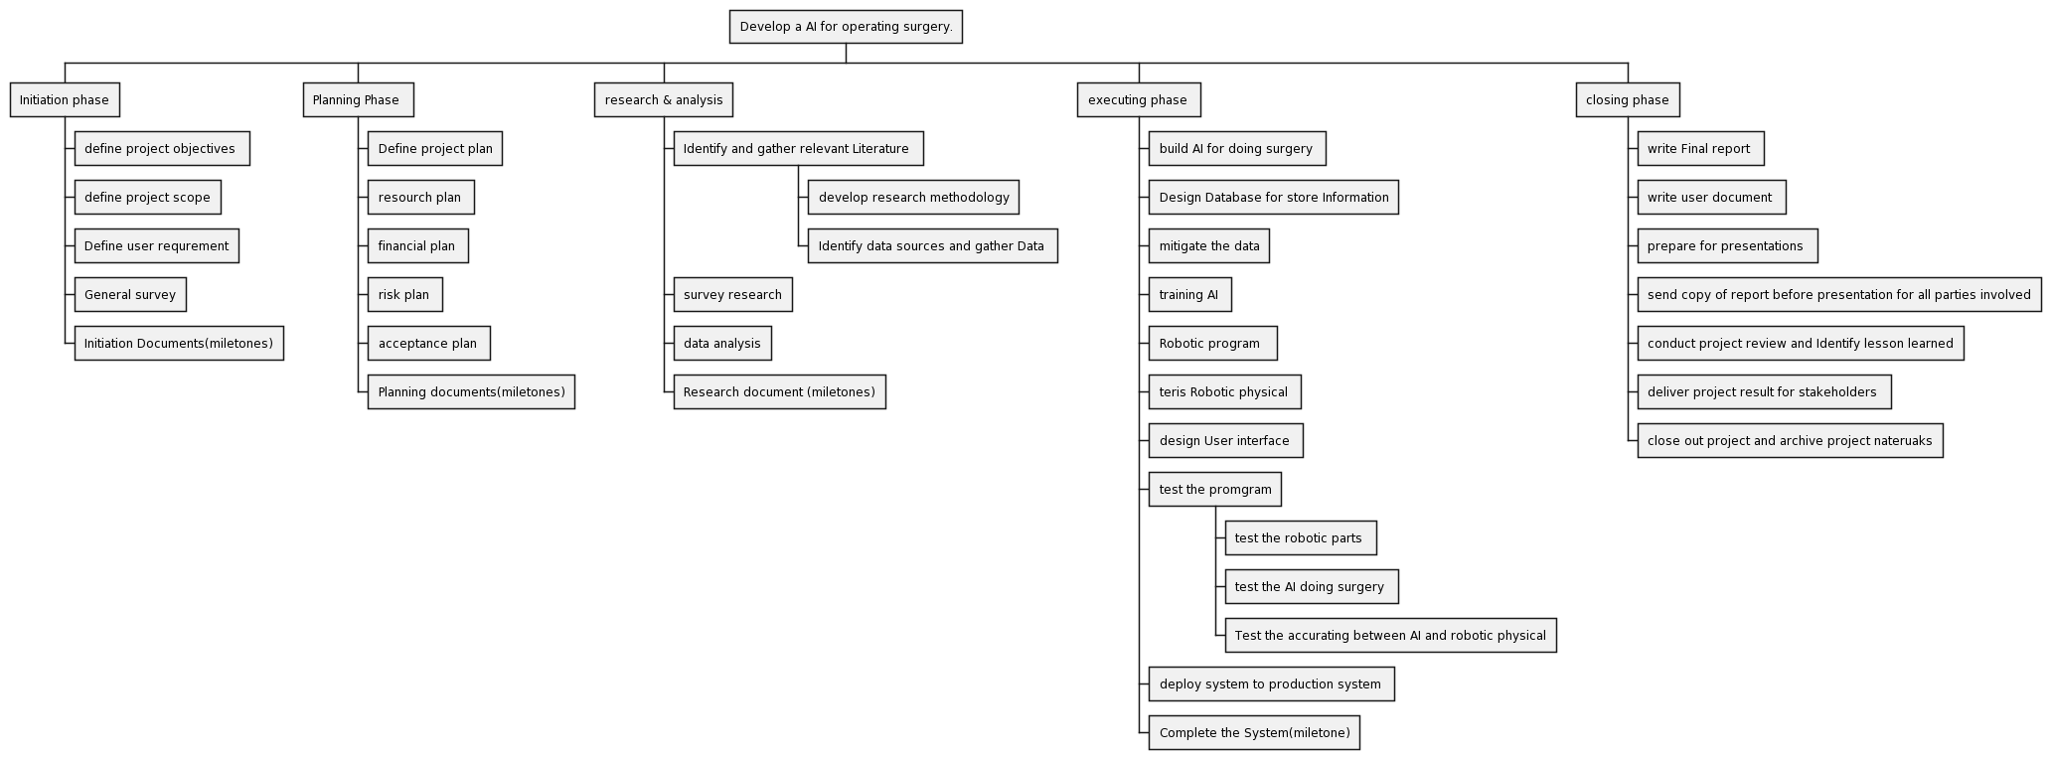

Figure work break-down structure

* 1. **Gannt chart**

A Gantt chart is a type of bar chart that illustrates a project schedule. This chart lists the tasks to be performed on the vertical axis, and time intervals on the horizontal axis. (wikipedia, n.d.)

|  |  |
| --- | --- |
| Phrase Initiation | Microsoft project |
| Phrase Initiation |  |
| Phrase Planning |  |
| Research Phrase |  |
| Executing phrase |  |
| Closing phrase |  |

Table Gannt chart

* 1. CPM

CPM stands for Critical Path Method, a project management technique used to plan and schedule projects. It helps identify the critical tasks and dependencies, estimating the time required to complete each task, and determining the overall project duration. CPM is widely used in project management software, including Microsoft Project and other project management tools.

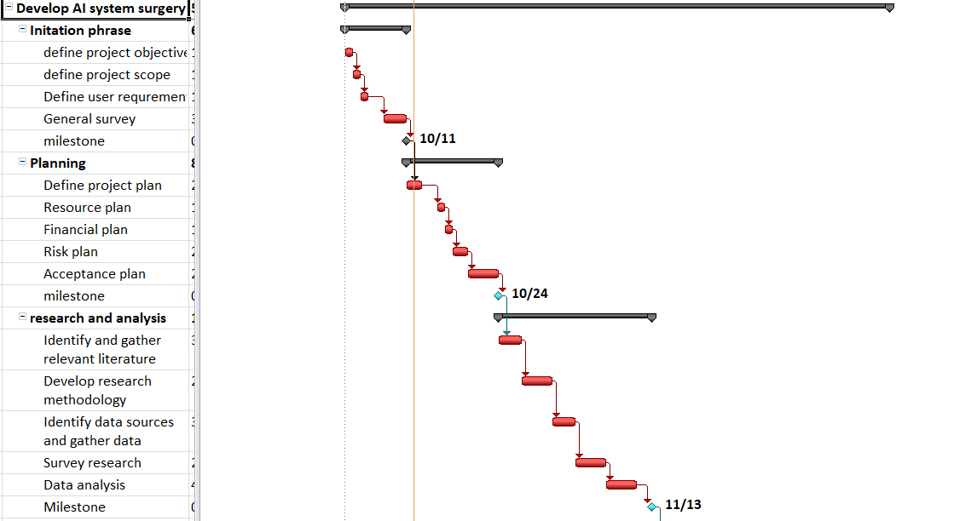

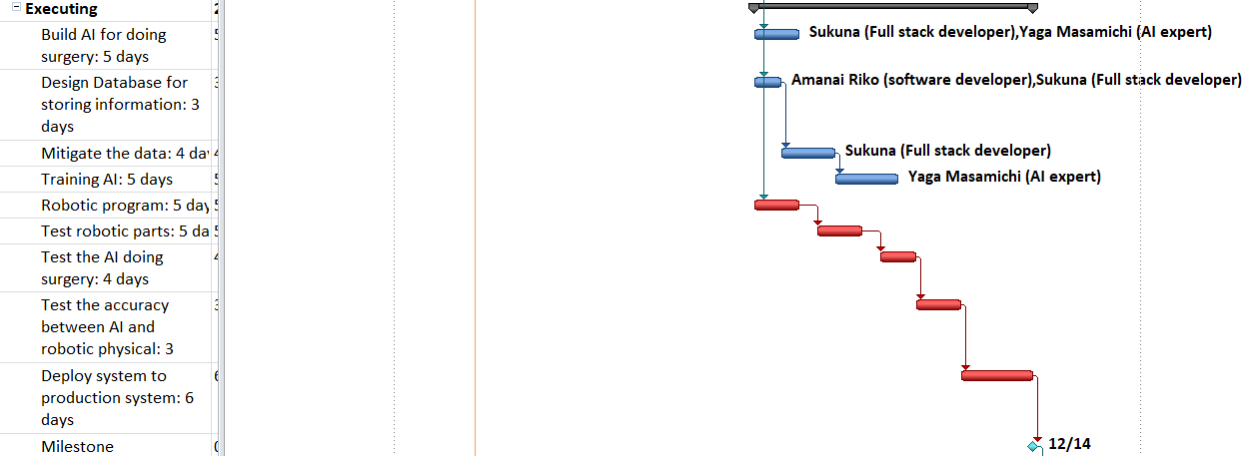

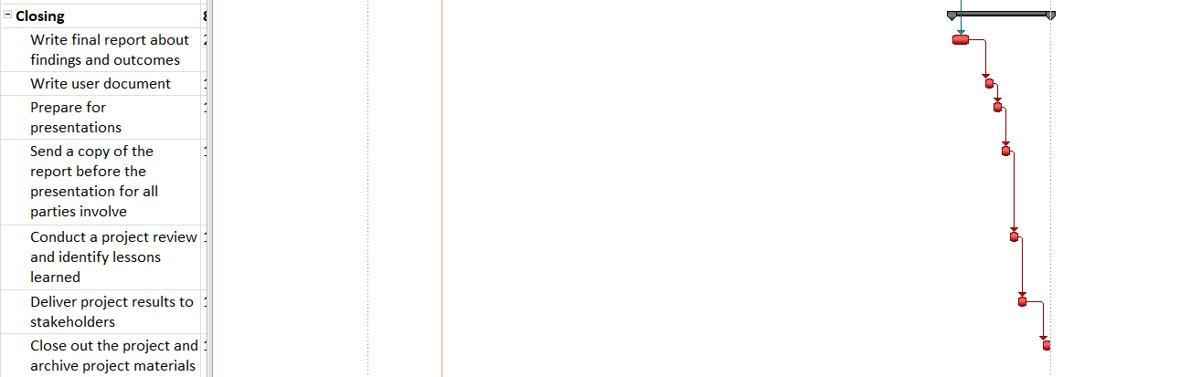

Figure CPM tasks

The red is cpm tasks, the blue is not include the cpm tasks it could deplay some couple of days

## V. Produce a comprehensive project management plan, milestone schedule and project schedule for monitoring and completing the aims and objectives of the project.M1

**5.1 microsoft project**

Microsoft Project is a project management software that helps you plan, manage, and deliver work effortlessly—from one-time projects to large initiatives. It is part of the Microsoft 365 suite of applications, and it can be used online or offline.

Some of the features of Microsoft Project are:

* Dynamic scheduling based on effort needed, project duration, and allotted team members
* Collaboration and communication tools with Microsoft Teams integration
* Portfolio and resource management to optimize your projects and resources
* Business intelligence and reporting with Power BI integration
* Customizable templates and methodologies to suit your needs

(microsoft, n.d.)

* The pros and cons of it

|  |  |
| --- | --- |
| **Pros** | **Cons** |
| Customizable features and APIs | Complex and time-consuming to learn and use |
| Agile project management | Expensive for single users or small teams |
| Advanced Gantt charts, budgeting, resource management, roadmapping, and reporting | Compatibility issues with different versions or tools |
| Automated scheduling | Not suitable for very small or simple projects |

Table . pros and cons of microsoft

(trustradius, n.d.)

**5.2 monitor**

Project monitoring and control is a phase in project management that occurs in tandem with the execution phase in the project life cycle. It is a project management phase that’s dedicated to measuring project performance and making sure that it adheres to what’s been set in the project plan. Project managers will closely track the progress and performance of the project, review project status, identify potential problems and implement corrective actions when required to keep the project on schedule and within budget. The process helps project teams discover problems before they occur. Monitor Key Performance Indicators (KPIs): Monitoring KPIs keeps project deliverables on track and performance up to date. Project managers use data on timelines, budgets, and quality to enable better decisions, make changes to avoid problems, and capitalize on opportunities. (projectmanager, n.d.)

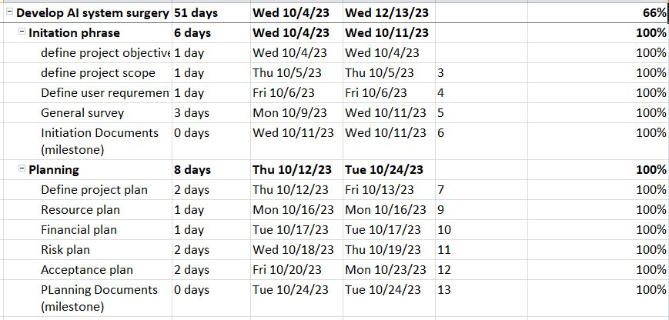

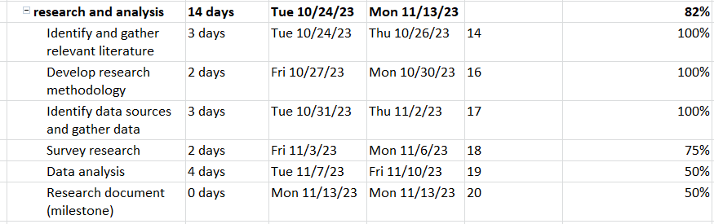

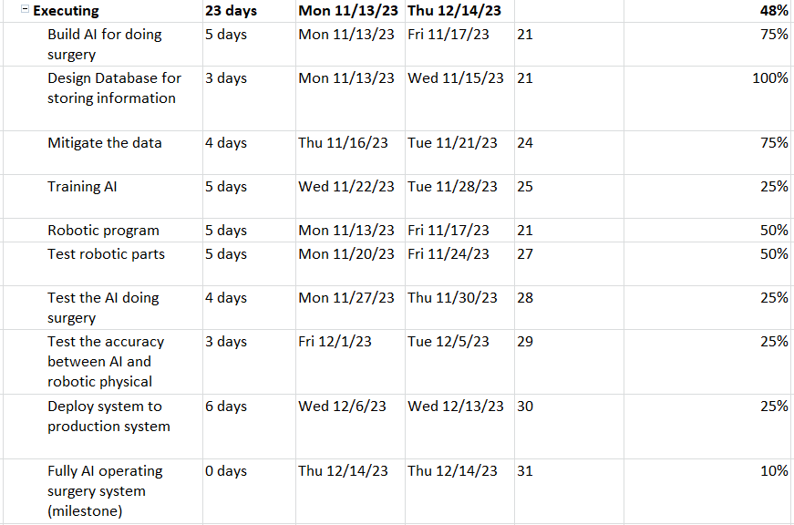

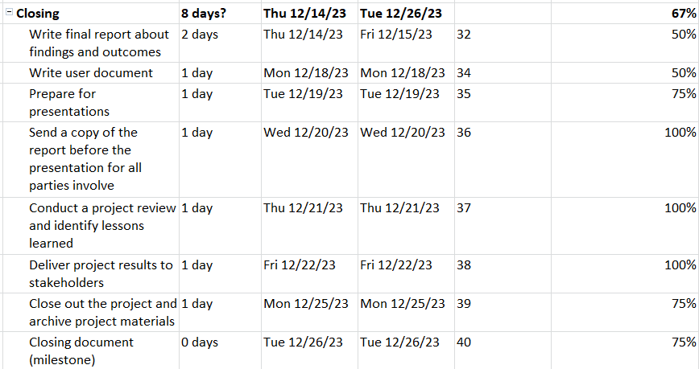

Figure monitor

# Part 2: Research

## Research study

**Research Process:**

 In the era of technology, research plays a crucial role in enhancing technology and discovering new applications. Sequential research, a simple yet effective method, involves a step-by-step process. First, you identify the area of study, which could be a specific product or service that your customers are interested in. Next, you define the topic of your research, which could be a specific question or problem that needs to be solved. Then, you decide on the best way to approach your research, which could involve conducting surveys or interviews with your customers in this phrase I will use Focus group. After that, you create a detailed plan for your research, including a timeline, budget, and necessary resources. You then start gathering information related to your topic from various sources such as online databases and websites. Once you’ve collected enough data, you analyze it to find patterns and trends that can help answer your research question. Finally, I represent my results in a clear and understandable way, such as through graphs or reports.

* 1. **Primary research**
* Primary research is the process of gathering new and unspecified information from original sources for this I’ll use Focus group about 10 people separate them into 3 group and let them discuss about problem. This includes collecting standardized data through methods such as surveys, interviews, direct observations, or field testing. Research charts provide specific guidance on research goals, especially individual needs or unique goals. Collect and map data used for analysis and decision making in the established strategic plan. (scribbr, n.d.)
  + 1. **qualitative research**

Qualitative research is a research approach that focuses on understanding the subjective experiences and perspectives of individuals and groups. Unlike quantitative research, which focuses on numerical data, qualitative research explores and interprets the meanings that people attach to their experiences and behaviors. The main aim is to gain a deep understanding of a social or cultural phenomenon from the perspective of those involved. (scribbr, n.d.)

* **Pros and cons**
* Pros

|  |  |
| --- | --- |
| **Affordability** | Qualitative research is one of the most affordable ways to glean information from individuals who are being studied. |
| **Predictive Element** | The data gathered provides a predictive element to the project. |
| **Focus on Personal Choice** | This research process looks at the purpose of the decision that an individual makes as the primary information requiring collection. |
| **Detailed Evaluation** | Subject materials can be evaluated with greater detail. |
| **Fluid Research Frameworks** | Research frameworks can be fluid and based on incoming or available data. |

Table pros of qualitive research

* Cons

|  |  |
| --- | --- |
| **Time-Consuming** | Qualitative research can be time-consuming to carry out. |
| **Requires Participant’s Time** | It requires participants to give some of their time. |
| **Limited Generalizability** | It can describe the range of user views, but not how common each view is. |
| **Reliance on Respondents’ Accuracy** | The research relies on respondents’ accuracy. |
| **Intensity** | Qualitative interviews can be intense in terms of time, expense, and possible emotional strain. |

Table cons of qualitative research

**1.1.1.1 Questions for qualitative research**

* In this part I’m going to take Hospital’s data and interview doctors who have done the surgeries or have observation.
* How does experience affect the success of surgery when the doctor has a good understanding of the knowledge of a surgery? Is the experience affect much in it
* What are the factors that influence the trust of patients and their families in AI to perform surgery?
* What are the risks and benefits of letting AI operate surgery without expert observation?
* What determines of the success of surgery?
* What are the unexpected situation likely happen during surgery?

**1.1.2 Quantitative research**

Quantitative research is the process of collecting and analyzing numerical data. It can be used to find patterns and averages, make predictions, test causal relationships, and generalize results to wider populations. (scribbr, n.d.)

* **Pros and cons**

|  |  |
| --- | --- |
| **Pros of Quantitative Research** | **Cons of Quantitative Research** |
| 1. Rapid Data Collection | 1. Lack of Context |
| 2. Randomized Samples | 2. Limited Flexibility |
| 3. Reliable and Repeatable Information | 3. Requires Expertise |

Table pros and cons of quantitalive resreach

* 1. **secondary research**

**Secondary research**is a research method that uses data that was collected by someone else. In other words, whenever you conduct research using data that already exists, you are conducting secondary research. On the other hand, any type of research that you undertake yourself is called primary research. (scribbr, n.d.)

* **pros and cons**

**Pros**:

Rapid Data Collection: Quantitative research involves surveys, experiments, and real-time gathering, which allows for rapid collection of data.

Randomized Samples: This research uses a randomized process to collect information, preventing bias from entering into the data.

Reliable and Repeatable Information: Quantitative research offers consistent results when the same data points are examined under randomized conditions.

Generalizable Findings: The results of quantitative research can be generalized to larger populations. (vittana, n.d.)

**Cons:**

Lack of Depth: Quantitative research can provide a broad overview, but it may lack depth in understanding individual perceptions and experiences.

Limited Context: Without the right context, the numerical data from quantitative research can sometimes be misleading.

Inflexibility: The structured and statistical nature of quantitative research can make it inflexible, limiting its ability to adapt to new information or insights during the study. (vittana, n.d.)

**1.3 Secondary Research papers:**

* **Paper title :Artificial Intelligence Surgery: How Do We Get to Autonomous Actions in Surgery?**

**Author: by Andrew A. Gumbs and Isabella Frigerio and Gaya Spolverato and Roland Croner and Alfredo Illanes and Elie Chouillard and Eyad Elyan(2021)**

* **Summarize the paper:**

comprehensive overview of various aspects of artificial intelligence (AI) and robotics in surgery. It covers the growth of AI in the field of surgery, the existence of autonomous actions, obstacles and challenges, the role of machine learning (ML), deep learning (DL), computer vision (CV), and natural language processing (NLP), as well as the ethical considerations. It discusses the potential for autonomous actions in surgery, data collection and annotation, the role of academic surgeons in AI and robotics, and the need for interdisciplinary collaboration between AI and medical communities.

Furthermore, it addresses the use of ML tools in surgery, objective assessment of surgeon performance, ML applications in healthcare, NLP in healthcare, value of reliable and decoded data from clinical notes, and NLP in predicting complications and surgical education. It also touches on traditional vs. deep models, advances in computer vision, transfer learning in cancer detection, object localization in medical image analysis, and the significance of reliable data and data annotation in advancing AI in surgery. Moreover, it talks about reinforcement learning (RL), imitation learning (IL), and the challenges of autonomous surgery.

The text highlights the importance of haptics in robotic surgery and discusses the potential of CNN-based frameworks in autonomously controlling guide wires, the role of noise in robotic surgery, and the use of ML algorithms in analyzing sensor data. It emphasizes the need for data collection and collaboration in advancing AI in surgery, and the complex interplay of ML, DL, CV, and NLP in autonomous actions.

Additionally, it encourages academic surgeons to consider gaining experience in AI and robotics, and it covers the classification of medical devices in AI surgery, levels of surgical autonomy and current applications. The potential of NLP in interpreting robotics data is discussed, as well as the debate over haptics in surgical robots. The text also highlights the potential of CNN-based frameworks in autonomously controlling guide wires.

This extensive text provides a detailed overview of the challenges and opportunities in AI and robotics in surgery, as well as the importance of ethical considerations. It discusses specific research papers and developments in the field, providing a comprehensive understanding of the topic.

* **Out-come of the Paper:**

**Improved Surgical Outcomes**: AI in surgery has the potential to improve patient outcomes by enabling more precise and efficient surgical procedures. For example, it can aid in decision-making and predicting complications.

**Predictive Capabilities**: ML(machine learning) and DL(deep learning can be used to predict various aspects of surgery, from predicting postsurgical mortality and ICU admission to predicting case-time duration.

**Data-Driven Decision Support**: AI can provide valuable data-driven decision support for surgeons, allowing them to make more informed choices during surgery.

**Automation**: objective of AI in surgery is to achieve the automation of specific surgical tasks, progressively advancing toward more self-sustaining robotic surgical procedures.

* **The Problems and Solution of the paper:**

**Problems:**

**Complex Interplay of Technologies**: Autonomous actions in robotic surgery require a complex interplay of machine learning (ML), deep learning (DL), computer vision (CV), and potentially natural language processing (NLP), which can be challenging to integrate effectively.

**Data Availability and Annotation**: Limited datasets designed for autonomous or semi-autonomous surgery can hinder research in the field. Annotating data for AI applications can be complex and time-consuming.

**Data Collection and Preparation**: The adoption of AI in surgery requires large volumes of annotated videos capturing surgical procedures, which can be time-consuming and resource-intensive.

**Solutions:**

**Unified** **Frameworks**: Develop unified frameworks that combine ML, DL, CV, and NLP technologies to work seamlessly together. Standardized APIs and interoperable models can facilitate this integration.

**Data Sharing:** Encourage the sharing of annotated surgical data within the research community. Establish repositories or platforms where researchers can contribute and access annotated surgical videos.

**Automation of Data Collection:** Explore the use of automated systems to capture and annotate surgical procedures. This could involve incorporating AI-powered cameras and sensors in operating rooms.

**Things I Still don’t Understand :**

I still do not understand Reinforcement Learning and Markov Decision Processes

* **Paper title: Evaluation of Deep Learning Models for Identifying Surgical Actions and Measuring Performance (2020)**

**Authors: Shuja Khalid, MSc; Mitchell Goldenberg, MBBS, PhD; Teodor Grantcharov, MD, PhD; et al**

**summarize :**

The study's primary objective was to assess surgical performance based on surgical video clips using deep learning models. To achieve this, the researchers utilized the Johns Hopkins University-Intuitive Surgical Gesture and Skill Assessment Working Set, a dataset comprising 103 surgical video clips. These videos included various surgical actions performed by eight surgeons, such as knot tying, needle passing, and suturing. Each video had been annotated with performance scores, which served as the basis for assessment.

The researchers employed two main methods for their analysis. First, they used autoencoders to transform video frames into compact, low-dimensional representations known as embeddings. These embeddings were used to train a neural network model to recognize surgical actions and performance measures. The second approach involved the use of key points to represent surgical instruments in the video frames, allowing for precise tracking of instrument orientation and position throughout the procedures.

To evaluate the performance of their models, the researchers used standard machine learning metrics such as precision, recall, and the F1 score. The results of their analysis were quite promising. The study found that the embedding representation approach achieved state-of-the-art results in the detection of surgical actions, boasting a mean precision of 91% and a mean recall of 94%. Additionally, the models were capable of predicting the surgical skill level of operators with a mean precision of 77% and a mean recall of 78%.

In conclusion, the research demonstrated the effectiveness of deep learning models in identifying surgical actions and evaluating surgical performance based solely on video data. The potential applications of these models include providing real-time feedback to surgeons, which could significantly contribute to skill enhancement. However, the study acknowledges the necessity for larger datasets and further refinement in the assessment of surgical performance.

**Outcome of problem:**

**Action Detection**: The deep learning models achieved a high level of accuracy in detecting surgical actions, with a mean precision of 91% and a mean recall of 94%. This means that the models were able to correctly recognize and categorize different surgical actions within the video clips.

**Performance Assessment**: The models were also capable of estimating the surgical skill level of the operators. They achieved a mean precision of 77% and a mean recall of 78% in predicting the skill levels, differentiating between novice, intermediate, and expert levels.

**Use of Visual Data**: Importantly, these outcomes were achieved solely by analyzing visual data from the surgical videos, without the need for additional kinematic data or robotic sensory data. This demonstrates the potential for real-time surgical performance assessment in a variety of surgical procedures.

**Problems**: ( made it shortly)

**Subjectivity and Error in Surgical Performance Assessment**: Human evaluation of surgery videos is subjective and error-prone

**Lack of Objective Evaluation Tools**: Assessment tools like OSATS are slow, need experts, and may be biased or hard to use.

**Things that I still do not understand:**

Objective Structured Assessment of Technical Skill (OSATS):

Surgical Terminology: suturing, knot tying.

Data Sets

Evaluation Metrics precision, recall, and F1 score

**1.1.3 the difference between qualitative and quantitative research**

|  |  |
| --- | --- |
| Qualitative methods | Quantitative methods |
| * Emphasize understanding and interpretation from the respondent’s point of view. * Use a rational approach to gather observations and measurements in natural settings. * Provide a subjective “insider view” with closeness to data. * Have an explorative orientation and are process-oriented. * Take a holistic perspective, considering the whole picture rather than breaking it down into separate parts. * Generalize by comparison of properties and contexts of individual organisms, rather than aiming for statistical generalization. | * Emphasize testing and verification, focusing on facts or reasons for social events. * Use a logical and critical approach with controlled measurements. * Provide an objective “outsider view”, maintaining distance from data. * Are hypothetical-deductive, focusing on hypothesis or theory testing. * Are result-oriented, focusing on outcomes rather than processes. * Take a particularistic and analytical approach, breaking down phenomena into separate parts to understand them. * Generalize by population membership, aiming for statistical generalization that can be applied to the entire population. |

Table difference between qualitative and quantitative research

(flm, n.d.)

**1.1.4. summary research**

* List of participants

|  |  |  |  |
| --- | --- | --- | --- |
| Participant name | Age | Gender | Job |
| Dr. Strange Stephen | 43 | Male | Surgical doctor |
| Dr. Bruce Banner | 60 | Male | Former surgeon |
| Dr. Jing Liu | 35 | Male | Surgical doctor |
| Dr. Wonder | 40 | Female | Surgical doctor |
| Dr. Yua Zin Zhao | 25 | Female | Nurse |
| Dr. America | 36 | Male | Surgical techs assist |
| Dr. Panther | 43 | Male | Surgical tech |
| Dr. Nami | 30 | Female | Physician assistant |
| Dr. Minami | 42 | Female | Surgical Doctor |
| Dr. Trung | 30 | Male | Surgical doctor |

Table list of participants

* Interview Summary

|  |  |
| --- | --- |
| Question | Expected outcome |
| How does experience affect the success of surgery when the doctor has a good understanding of the knowledge of a surgery? Is the experience affect much in it | Information gather could be use to evaluate that a surgery could perform only by Knowledge and information without experience |
| What are the factors that influence the trust of patients and their families in AI to perform surgery? | Information gather could be use to evaluate that how to made patient willing to let AI operating their surgery |
| What are the risks and benefits of letting AI operate surgery without expert observation? | Information gather could be use to evaluate that is it possible to let AI perform fully automatic without expertise observation |
| What determines of the success of surgery? | Information gather could be use to evaluate the key point to success of a surgery |
| What are the unexpected situation likely happen during surgery? | Information gather could be use to evaluate that consider to let AI training to handle unexpected situation during operating surgery |

Table interview summary

* Survey Summary

|  |  |
| --- | --- |
| Question | Expected outcome |
| * From scale 1-5(1 is the smallest) what is your rate at the rate of unexpected condition happen to patient while operating complexity surgery | * The information gathered could be use to evaluate the likely happen of unexpected situation during complex Surgery |
| * From scale 1-5(1 is the smallest) what is your rate at the rate of unexpected condition happen to patient while operating simple/ moderate complexity surgery | * The information gathered could be use to evaluate the likely happen of unexpected situation during simple/ moderate Surgery |
| * What are the factor that could affect the survival ratio of patient during the surgery (factors: Heart rate, Body temperature, Breathing rate, Blood pressure, Brainwave.) | * The information gathered could be use to evaluate that which are the important factors of patient could affect the survival ratio |
| * What is the patient's condition factors that you are think that important during surgery (factors: Heart rate, Body temperature, Breathing rate, Blood pressure, Brainwave.) | * The information gathered could be use to evaluate that what is the most important factors of patient during the surgery |
| * From the scale 1-5(1 is the smallest) what is your rate at the important of experience in surgery | * The information gathered could be use to evaluate the important of experience in surgery |

Table survey summary

## Evaluate the accuracy and reliability of different research methods applied. (M2)

2.1 Evaluate the interview and survey

|  |  |  |  |
| --- | --- | --- | --- |
| **Question** | **Reasoning** | **Accuracy** | **Reliability** |
| How does experience affect the success of surgery when the doctor has a good understanding of the knowledge of a surgery? Is the experience affect much in it | I want to know that is the experience matter much in surgery because AI have no concept of experience it will be strictly if experience matter much in surgery. | this question Accurate is high( 75%) because the question focus on experience of doctor in operating surgery the output may be experience of doctor with unexpected situation or some situation that doctor must apply personal experience. | This question quite Reliable because the question focus on doctor experience |
| What are the factors that influence the trust of patients and their families in AI to perform surgery? | I want to Know what factors influence the trust of patient to made them trust and let AI to Hold their Surgery | This question accuracy might in average ( about 50%) because doctors may don't really know about what factors influence the trust of patient the Accuracy might depend on Role of person who being asked | Because this question base on Personal experience it might work for somebody but not everyone so reliability is about 50% |
| What are the risks and benefits of letting AI operate surgery without expert observation? | I want to know the point of view(POV) of expert that it is okay to letting a single system handling a life what if there is error occur or something like that | because the System is not able to perform in real life there is no information to test it out so that the accuracy of this question is not so accuracy and it depends on the trust of expertise to new technology | It not so high as I was relate that the system is not perform and it depend on human so the reliability not so high |
| What determines of the success of surgery? | I want to understand the various factors that contribute to the success of a surgical procedure. | The accuracy of this question is relatively high (around 75%) because it seeks to identify the key factors that impact surgical success, and there is existing medical knowledge on this topic. | The reliability of this question is also relatively high (around 70%) because the success of surgery is a well-researched topic in the medical field, and experts can provide reliable information on the factors that contribute to success. |
| What are the unexpected situation likely happen during surgery? | I want to gain insight into the potential unforeseen circumstances or complications that can arise during surgical procedures | The accuracy of this question is high (around 80%) because unexpected situations during surgery are well-documented in the medical field, and there is existing knowledge on this topic. | The reliability of this question is also relatively high (around 75%) because medical experts and literature can provide information about unexpected situations that may occur during surgery. |
| From scale 1-5(1 is the smallest) what is your rate at the rate of unexpected condition happen to patient while operating complexity surgery | I want to understand the perceived frequency of unexpected medical conditions during intricate surgeries from the perspective of healthcare professionals. | The accuracy of this question is relatively high (around 70%) because medical professionals can provide insights into the likelihood of unexpected conditions during complex surgeries. | The reliability of this question depends on the expertise of the individuals being surveyed. If the respondents are experienced healthcare professionals, the reliability is likely to be high (around 75%). |
| From scale 1-5(1 is the smallest) what is your rate at the rate of unexpected condition happen to patient while operating simple/ moderate complexity surgery | I aim to assess the perceived frequency of unexpected medical conditions during less complex and moderately complex surgical procedures, as this can provide insights into the level of predictability in these surgeries. | The accuracy of this question is relatively high (around 70%) because medical professionals can share their insights based on their experiences. | The reliability of this question depends on the expertise of the individuals being surveyed. If the respondents are experienced healthcare professionals, the reliability is likely to be high (around 75%). |
| What are the factor that could affect the survival ratio of patient during the surgery (factors: Heart rate, Body temperature, Breathing rate, Blood pressure, Brainwave.) | I want to explore the factors that may impact a patient's survival during surgery, specifically focusing on vital signs and brainwave activity, which are crucial indicators of a patient's well-being during medical procedures. | The accuracy of this question is relatively high (around 75%) because there is existing medical knowledge and research on how vital signs and brainwave activity can affect patient outcomes during surgery. | The reliability of this question is also relatively high (around 70%) because healthcare professionals and medical literature can provide reliable information on these factors. |
| What is the patient's condition factors that you are think that important during surgery (factors: Heart rate, Body temperature, Breathing rate, Blood pressure, Brainwave.) | I want to understand the perspective of healthcare professionals regarding the critical patient condition factors that should be closely monitored during surgical procedures, encompassing vital signs and brainwave activity. | The accuracy of this question is relatively high (around 75%) because medical professionals can provide insights based on their expertise and knowledge. | The reliability of this question depends on the expertise of the individuals being surveyed. If the respondents are experienced healthcare professionals, the reliability is likely to be high (around 70%). |
| From the scale 1-5(1 is the smallest) what is your rate at the important of experience in surgery | I aim to assess the perceived importance of experience in the field of surgery, as this can provide insights into the value placed on a surgeon's level of expertise. | The accuracy of this question is relatively high (around 70%) because it can capture the subjective opinions of healthcare professionals regarding the importance of experience in surgery. | The reliability of this question depends on the expertise and perspectives of the individuals being surveyed. If the respondents are experienced healthcare professionals, the reliability is likely to be high (around 70%). |

Table Evaluate the interview and survey

2.2.Evaluate the secondary research

According to papers in secondary research it is possible to create a system that automatic operating surgery via the technologies that paper was relate before in this paragraph I’ll evaluate the outcome of paper which relate to my project. Two paper provide information for that deep learning models were trained to estimate categorical outputs such as performance level (ie, novice, intermediate, and expert) and surgical actions (ie, knot tying, suturing, and needle passing). The efficacy of these models was measured using precision, recall, and model accuracy and The article discusses the feasibility and potential of autonomous actions in surgery, specifically focusing on the role of artificial intelligence (AI) in the field. It highlights that while many surgeons are skeptical about the possibility of autonomous actions, examples of AI in surgery, such as machine learning, deep learning, computer vision, and natural language processing, already exist. First of all it is Predictive Capabilities, Machine learning and deep learning models for predicting various aspects of surgery align with your project's focus on AI-driven decision support. Predicting complications and case-time duration can aid surgeons in making informed choices during surgery with these I could use to train my AI to made decision the technologies in the paper was just assist for surgeons but with the improve of AI during the training the AI must be able to choose the right decision on it-own. Further more, the AI is able to made right decision is Data-Driven Decision support, in the paper it relate that AI providing data-driven decision support for surgeons. It highlights the role of AI in assisting surgeons by offering valuable insights based on data analysis which mean AI have logically analysis and then give decision logically which is hard for human even expertise in some case. Secondly, the paper relate that there is technologies that help AI to detect action ,High accurate in action is one of the most key to able AI and robotic operating surgery the accurate of driven robotic base on decision of AI could be evaluate by it self by rating system based on action detection, out-come of rating action could be valuable for AI learning it-self, the paper relating to this research underscores the use of visual data and its alignment with the potential for real-time surgical performance assessment. This feature holds particular significance to my project base on the information could be lean direct by video, it could be large amount of information and valuable for training AI at lower cost.

# References

Anon., n.d. https://en.wikipedia.org/wiki/Work_breakdown_structure ed. s.l.:s.n.

asana, n.d. [Online]   
Available at: https://asana.com/resources/project-initiation

asana, n.d. https://asana.com/resources/cost-management-steps ed. s.l.:s.n.

britannica, n.d. [Online]   
Available at: https://www.britannica.com/topic/communication/Dynamic-models

coursera, n.d. [Online]   
Available at: https://www.coursera.org/articles/time-management

flm, n.d. [Online]   
Available at: https://flm.greenwich.edu.vn/gui/role/guest/ListScheduleSyllabus?subjectCode=dVLUFBcCd/bB0FetqDQhGw==&SessionNo=F9EHvqN+dUjlw7x5OhB/aQ==

flm, n.d. Issue https://flm.greenwich.edu.vn/gui/role/guest/ListScheduleSyllabus?subjectCode=dVLUFBcCd/bB0FetqDQhGw==&SessionNo=F9EHvqN+dUjlw7x5OhB/aQ==.

forbes, n.d. [Online]   
Available at: https://www.forbes.com/advisor/business/what-is-project-management/

geeksforgeeks, n.d. [Online]   
Available at: https://www.geeksforgeeks.org/software-engineering-project-management-process/

ibm, n.d. Issue https://www.ibm.com/topics/risk-management.

it.ox.ac.uk, n.d. [Online]   
Available at: https://www.it.ox.ac.uk/article/what-is-an-it-project#:~:text=And%20what%20exactly%20is%20a%20project%3F%20A%20standard,either%20deliver%20new%20services%20or%20enhance%20existing%20ones.

javatpoint, n.d. [Online]   
Available at: https://www.javatpoint.com/software-project-management#:~:text=Software%20project%20management%20is%20an%20art%20and%20discipline,resources%20to%20develop%20computer%20software%20that%20fulfills%20requirements.

kissflow, n.d. [Online]   
Available at: https://kissflow.com/project/project-scope-management/

microsoft, n.d. Issue https://www.microsoft.com/en-us/microsoft-365/project/project-management-software.

projectmanager, n.d. Issue https://www.projectmanager.com/blog/project-monitoring-and-control.

scribbr, n.d. https://www.scribbr.com/methodology/primary-research/ ed. s.l.:s.n.

scribbr, n.d. https://www.scribbr.com/methodology/primary-research/ ed. s.l.:s.n.

scribbr, n.d. Issue https://www.scribbr.com/methodology/secondary-research/.

scribbr, n.d. [Online]   
Available at: https://www.scribbr.com/methodology/quantitative-research/

trustradius, n.d. Issue https://www.trustradius.com/products/microsoft-project/reviews?qs=pros-and-cons.

vittana, n.d. https://vittana.org/13-pros-and-cons-of-quantitative-research-methods ed. s.l.:s.n.

wikipedia, n.d. https://en.wikipedia.org/wiki/Gantt_chart#:~:text=A%20Gantt%20chart%20is%20a%20type%20of%20bar,axis%2C%20and%20time%20intervals%20on%20the%20horizontal%20axis. ed. s.l.:s.n.

wrike, n.d. https://www.wrike.com/project-management-guide/faq/what-is-a-resource-in-project-management/ ed. s.l.:s.n.